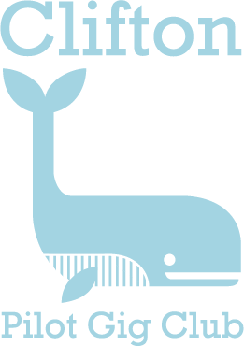
ANNUAL MEMBERSHIP FORM 2022

1st February 2022 to 31st January 2023

Trial rows – you are entitled to 3 rows for £10 after which Membership is required to meet ours and CPGA Insurance requirements.

Membership Type | Fee
Junior (8 – 16) | £30
Student (18 yrs. old or less) | £50
Adult student | £90
Adult | £150
Family | £200

Members participating in rowing sessions and other events organised by Clifton Pilot Gig Club do so entirely at their own risk and the Club accepts no responsibility for personal injury or loss as a result of any involvement whatsoever.

Members are also reminded that they must be medically fit to row and adhere to the Club’s and the CPGA Health & Safety Guidelines.

Rowers Contact details (family memberships - enter the name of each rower and their DOB)
Name: | DOB:
Address:  Post code: | Tel no:  Mob no:  E-mail:

Next of Kin details to be used in event of an Emergency
Name: | Relationship:
Address:  Post code: B | Tel no:  Mob no:  E-mail:

Please complete this form and return to Clifton Pilot Gig Club, 61 Queens Square, Bristol. BS1 4JZ.

Payment can be made by cheque or bank transfer to -
Barclays Bank Account: 63495442
Sort Code: 20 13 45

